To Change the Start Room
Select the room
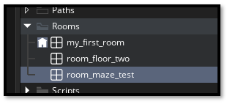
Go to the top of the Asset Browser and click the Hamburger menu
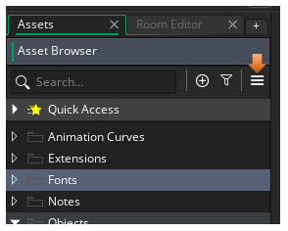
Select Room Manager
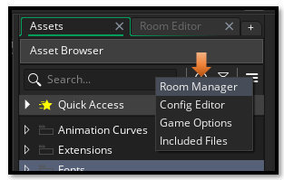
Select the room that you want to be first, and then hit this first icon at the bottom to send it to the top.
